ST. MICHAEL’S CATHOLIC GRAMMAR SCHOOL

Nether Street 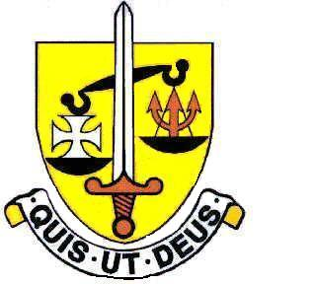 Voluntary Aided
North Finchley “An outstandingly effective School” Ofsted

London N12 7NJ
Tel: 020 8446 2256

Email: applications@st-michaels.barnet.sch.uk

4 Form Entry Voluntary Aided Grammar School for Girls with Boys in the Sixth Form
858 on Roll. 280 in Sixth Form.

Cover Supervisor
Barnet Unified Reward Grade C Max (currently £14.22 per hour)
Required to work as and when needed

Required as soon as possible.

The Governors are seeking to appoint Cover Supervisors to work on a flexible basis covering in classrooms across all subject areas where the teacher is absent. Availability can be negotiated with the School for those who wish to work particular days of the week.

This person will work under the direction of the Cover & Attendance Administrator. Ideally suited to this role would be someone with excellent communication skills and a highly organised approach. Interested candidates could also be required to provide cover for the school's Medical Room - in which case First Aid training will be provided.

A Support Staff application form and Job Description are available on our website.

Please send completed applications to applications@st-michaels.barnet.sch.uk.

We are committed to safeguarding and promoting child welfare
The post is subject to an enhanced DBS check
St Michael’s is an equal opportunities employer - applications are welcome from all sections of the community

