ST. MICHAEL’S CATHOLIC GRAMMAR SCHOOL

Nether Street 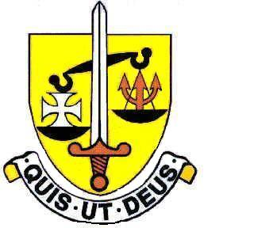 Voluntary Aided
North Finchley “An outstandingly effective School” Ofsted

London N12 7NJ
Tel: 020 8446 2256 Email: office@ st-michaels.barnet.sch.uk
Fax: 020 8343 9598 Website: www.st-michaels.barnet.sch.uk

4 Form Entry Voluntary Aided Grammar School for Girls with Boys in the Sixth Form
890 on Roll. 250 in Sixth Form.
Deputy Headteacher
Leadership Group L24 to L28 Outer London
Required for September 2025

Applicants for this post must be practising Roman Catholics.
The Governors invite applications for this important position joining a successful Senior Leadership Team at this selective school which has been four times judged OUTSTANDING by OFSTED, the most recent Inspection being November 2022. The school was judged Outstanding in a Catholic Schools Inspection in October 2024. The role offers an exciting opportunity for school leadership and provides an excellent preparation for Headship.

The postholder will take strategic responsibility for the pastoral care, wellbeing and safeguarding of students across key stages. Areas of responsibility will be negotiated in response to the specific skills and experience the successful applicant brings, together with the needs of the school.

We are seeking to appoint a well-qualified professional of proven experience who:
- Is a committed, practising Catholic with the vision, drive and energy to support and develop the School’s Catholic ethos.
- Has an ability to work in partnership with the rest of the Senior Leadership Team to maintain and improve the quality of teaching and learning.
- Has the intellect to initiate and manage change.
- Has strong managerial and leadership skills.

The school provides a very rewarding working environment where employees are valued and there is a focus on staff welfare.

An application form and job description are available on the school website and should be sent to applications@st-michaels.barnet.sch.uk

Closing date: Friday 21st March 2025 – midday. Early applications are encouraged as we reserve the right to call candidates to interview before this advert is withdrawn.
We are committed to safeguarding and promoting child welfare
The post is subject to an enhanced DBS check
St Michael’s is an equal opportunities employer - applications are welcome from all sections of the community

