ST. MICHAEL’S CATHOLIC GRAMMAR SCHOOL

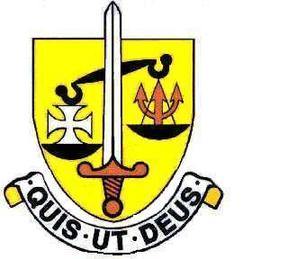

**North Finchley *“An outstandingly effective School” Ofsted***

# London N12 7NJ

**Tel: 020 8446 2256**

**Email:** [**applications@st-michaels.barnet.sch.uk**](mailto:applications@st-michaels.barnet.sch.uk)

4 Form Entry Voluntary Aided Grammar School for Girls with Boys in the Sixth Form

890 on Roll. 250 in Sixth Form.

**Full or Part-time Teacher of Design & Technology**

**Salary – Main or Upper Scale**

Required 1st September 2025

A fantastic opportunity to work with class sizes of sixteen engaged, intelligent and truly delightful students, who adore the subject. The department is well equipped, in its own block with all members of staff having been here for years, a retirement has created this chance to join us, a team that is flexible in its approach and welcomes new ideas.

The Governors are seeking to appoint an enthusiastic and well-qualified graduate Teacher of Design & Technology to this selective school which has been FIVE times judged OUTSTANDING by OFSTED, the most recent Inspection being November 2022.

This opportunity will ideally suit someone who enjoys teaching well-motivated and intelligent pupils in an academic school which is committed to the ideals of Catholic education – the school was judged Outstanding in a Catholic Schools Inspection in November 2024. Applications from experienced teachers are welcome but the existing expertise within the department means that this position is equally suited to an Early Career Teacher. For full-time applicants, offering a second subject would be an advantage.

The Technology Rooms are in a modern block equipped with all the latest implements to aid teaching, from a laser cutter to two 3D printers. There are also two computer suites of 16 PCs. The department has a dedicated Design and Technology Technician.

The school provides a very rewarding working environment where employees are valued and there is a focus on staff welfare.

An application form and job description are available on the school website.

Please send completed applications to [applications@st-michaels.barnet.sch.uk](mailto:applications@st-michaels.barnet.sch.uk).

Closing date: Tuesday 22nd April 2025 Midday – **early applications are encouraged as we reserve the right to call candidates to interview before this advert is withdrawn.**

We are committed to safeguarding and promoting child welfare

The post is subject to an enhanced DBS check

Shortlisted candidates will be subject to an online search

St Michael’s is an equal opportunities employer - applications are welcome from all sections of the community