ST. MICHAEL’S CATHOLIC GRAMMAR SCHOOL

Nether Street 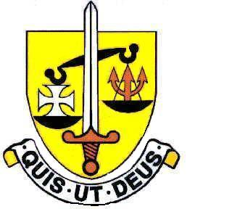 Voluntary Aided
North Finchley “An outstandingly effective School” Ofsted

London N12 7NJ
Tel: 020 8446 2256

Email: applications@st-michaels.barnet.sch.uk

4 Form Entry Voluntary Aided Grammar School for Girls with Boys in the Sixth Form
890 on Roll. 250 in Sixth Form.
Full or Part-time Teacher of Design & Technology
Salary – Main or Upper Scale
Required 1st September 2025

The Governors are seeking to appoint an enthusiastic and well-qualified graduate Teacher of Design & Technology to this selective school which has been FIVE times judged OUTSTANDING by OFSTED, the most recent Inspection being November 2022.

The successful candidate will join an experienced Design & Technology Department which achieves outstanding results at GCSE, with a well established course. The school is currently considering re-introducing A Level Product Design from September 2025.

This opportunity will ideally suit someone who enjoys teaching well-motivated and intelligent pupils in an academic school which is committed to the ideals of Catholic education – the school was judged Outstanding in a Catholic Schools Inspection in November 2024. Applications from experienced teachers are welcome but the existing expertise within the department means that this position is equally suited to an Early Career Teacher. For full-time applicants, offering a second subject would be an advantage.

The Technology Rooms are in a modern block equipped with all the latest implements to aid teaching, from a laser cutter to two 3D printers. There are also two computer suites of 16 PCs. The department has a dedicated Design and Technology Technician.

The school provides a very rewarding working environment where employees are valued and there is a focus on staff welfare.

An application form and job description are available on the school website.
Please send completed applications to applications@st-michaels.barnet.sch.uk.

Closing date: Monday 3rd February 2025 Midday – early applications are encouraged as we reserve the right to call candidates to interview before this advert is withdrawn.

We are committed to safeguarding and promoting child welfare
The post is subject to an enhanced DBS check
Shortlisted candidates will be subject to an online search
St Michael’s is an equal opportunities employer - applications are welcome from all sections of the community

