ST. MICHAEL’S CATHOLIC GRAMMAR SCHOOL

Nether Street 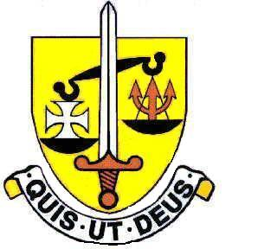 Voluntary Aided
North Finchley “An outstandingly effective School” Ofsted

London N12 7NJ
Tel: 020 8446 2256 Email: office@ st-michaels.barnet.sch.uk
Fax: 020 8343 9598 Website: www.st-michaels.barnet.sch.uk

4 Form Entry Voluntary Aided Grammar School for Girls with Boys in the Sixth Form
860 on Roll. 280 in Sixth Form.

Temporary Director of Music
Main or Upper Pay Scale – TLR 1b (currently £10,723)

To start 1st September 2023 - one term only – to 31st December 2023

The Governors are seeking to appoint a committed and enthusiastic teacher of Music to lead the Music Department for the Autumn Term 2023. The ideal candidate will bring an energetic and innovative approach to the teaching of Music throughout the age range. The students are enthusiastic and talented and the subject is very popular at St. Michael’s.

The successful candidate will be expected to take charge of the teaching of Music in a vibrant well-established department committed to fostering a love of music in students through choirs, orchestras and instrumental teaching. Music accommodation and facilities are modern having benefitted from a refurbishment.

The person appointed will be a well-qualified teacher who can communicate interest and enthusiasm for the subject in this selective school, FIVE times judged OUTSTANDING by OFSTED (the most recent Inspection being November 2022) which is committed to the ideals of Catholic education and where exam results are consistently excellent. As well as an ability to inspire students in their learning, the successful applicant should have an interest in a wide range of musical styles, be able to lead and manage a large peripatetic team, organise public performances and school productions and take a lead in the musical aspects of liturgy.

The school provides a very rewarding working environment where employees are valued and there is a focus on staff welfare.

An application pack is available on the school website. Please send completed forms to applications@st-michaels.barnet.sch.uk.

Closing date: Monday 26th June 2023 midday – early applications are encouraged as we reserve the right to call candidates to interview before this advert is withdrawn.

We are committed to safeguarding and promoting child welfare. The post is subject to an enhanced DBS check. St Michael’s is an equal opportunities employer - applications are welcome from all sections of the community

