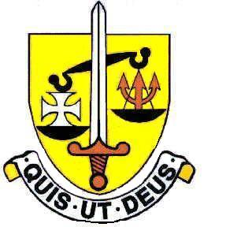

FORM 3

EVIDENCE OF FIRST HOLY COMMUNION

This is to certify that (child's name in full) __________________________________

Date of Birth: _________________ of (address in full) ________________________

___________________________________________________________________

made her First Holy Communion on (date) _________________________________

at (name and address of parish) _________________________________________

___________________________________________________________________

You must complete either Part 1 or 2
tick
1. * I enclose a copy of her Remembrance of First Holy Communion 

or

2. *Signature and Parish Stamp of Holy Communion

Priest’s name _______________________________________________________

Parish _____________________________________________________________

Address ___________________________________________________________
Priest’s signature
________________________________________

Date_______________________

Parish stamp or seal

Date ________________________________ Telephone _____________________

This form should be returned directly to the Headteacher at St. Michael’s by the closing date stated on the associated Supplementary Information Form. Failure to complete it or return it would prevent the Governors applying their Admissions Criteria to your Application for a place at St Michael’s for your daughter.

*Please delete as necessary

