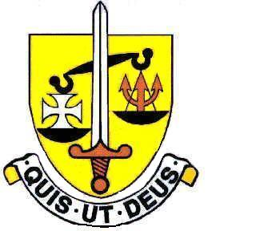

ST. MICHAEL’S CATHOLIC GRAMMAR SCHOOL

TERM DATES 2022/2023

AUTUMN TERM 2022
First Half: Thursday 1st September - Friday 21st October
INSET Thursday 1st September pm - Yr12 Enrolment
Friday 2nd September - Year 7 start
Monday 5th September – Years 8-13 return

Half-term: Monday 24th October – Friday 28th October

Second Half: Monday 31st October – Friday 16th December
INSET Monday 31st October
Christmas holiday Monday 19th December – Monday 2nd January

SPRING TERM 2023

First Half: Tuesday 3rd January – Friday 10th February
INSET Tuesday 3rd January
INSET Wednesday 4th January
Half-term: Monday 13th February – Friday17th February

Second Half: Monday 20th February – Friday 31st March
Easter holiday Monday 3rd April – Friday 14th April
(Easter weekend 7th to 10th April)

SUMMER TERM 2023

First Half: Monday 17th April - Friday 26th May
(May Day Bank Holiday: Monday 1st May)
(Coronation Bank Holiday: Monday 8th May)

Half-term: Monday 29th May - Friday 2nd June
(Spring Bank Holiday: 29th May)

Second Half: Monday 5th June – Friday 21st July
INSET Monday 3rd July

(Total number of Days 195 (includes 5 INSET Days)

