Travelling to St Michael’s

St Michael’s is well served by public transport and we encourage students to use buses and tubes to travel to school, rather than parents needing to drive them to school every day. Travelling to school independently encourages friendships with girls living in a similar area and teaches students to be aware of their surroundings and personal safety. The school is located near North Finchley Bus Station and Woodside Park Tube Station (Northern Line). North Finchley Bus Station is a 5-minute walk from the school and Woodside Park Tube Station is approximately 10-minute walk.

Superloop Routes

Two new Superloop bus routes were introduced in late 2023. These routes provide direct free bus travel (for under 16s) to St Michael’s.

SL1 - Walthamstow to North Finchley
The SL1 gives direct access from Walthamstow Bus Station via Edmonton , Palmers Green, Arnos Grove and New Southgate and takes approximately 45 minutes. It follows the route shown below:

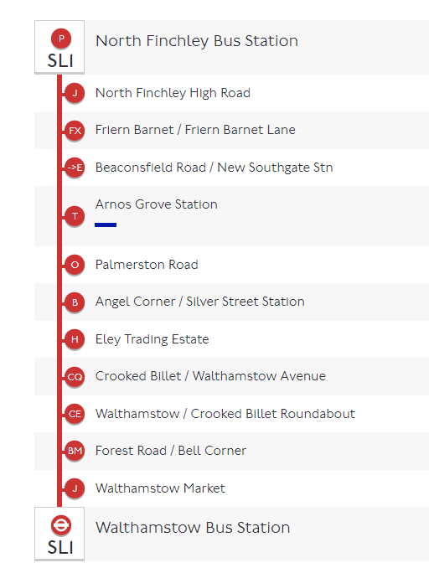
SL10 - Harrow to North Finchley
The SL10 gives direct access from Harrow Bus Station via Kenton, Kingsbury, Hendon and Finchley Central and takes approximately 1 hour. It follows the route shown below:
