**ST. MICHAEL’S CATHOLIC GRAMMAR SCHOOL**

“Love one another as I have loved you”

(John 15:12)

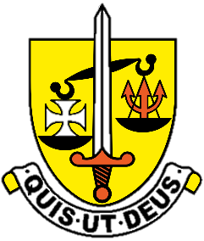

**Year 9 GCSE Options 2025**

**CONTENTS:**

|  |  |
| --- | --- |
| Introduction | 3-4 |
| Curriculum at KS4 | 5 |
| **CORE SUBJECTS:** | |
| Religious Studies | 6 |
| English and English Literature | 7 |
| Mathematics | 8 |
| Sciences | 9 |
| **OPTIONAL SUBJECTS** |  |
| Art and Design | 10 |
| Computer Science | 11 |
| Design and Technology | 12 |
| Drama | 13 |
| Food and Nutrition | 14 |
| Geography | 15 |
| History | 16 |
| Latin | 17 |
| Modern Foreign Languages | 18 |
| Music | 19 |
| PE | 20 |
| Separate Sciences | 21 |
| **ADDITIONAL INFORMATION** |  |
| Pastoral curriculum | 22 |
| Work experience | 23 |
| Options Form | 24 |

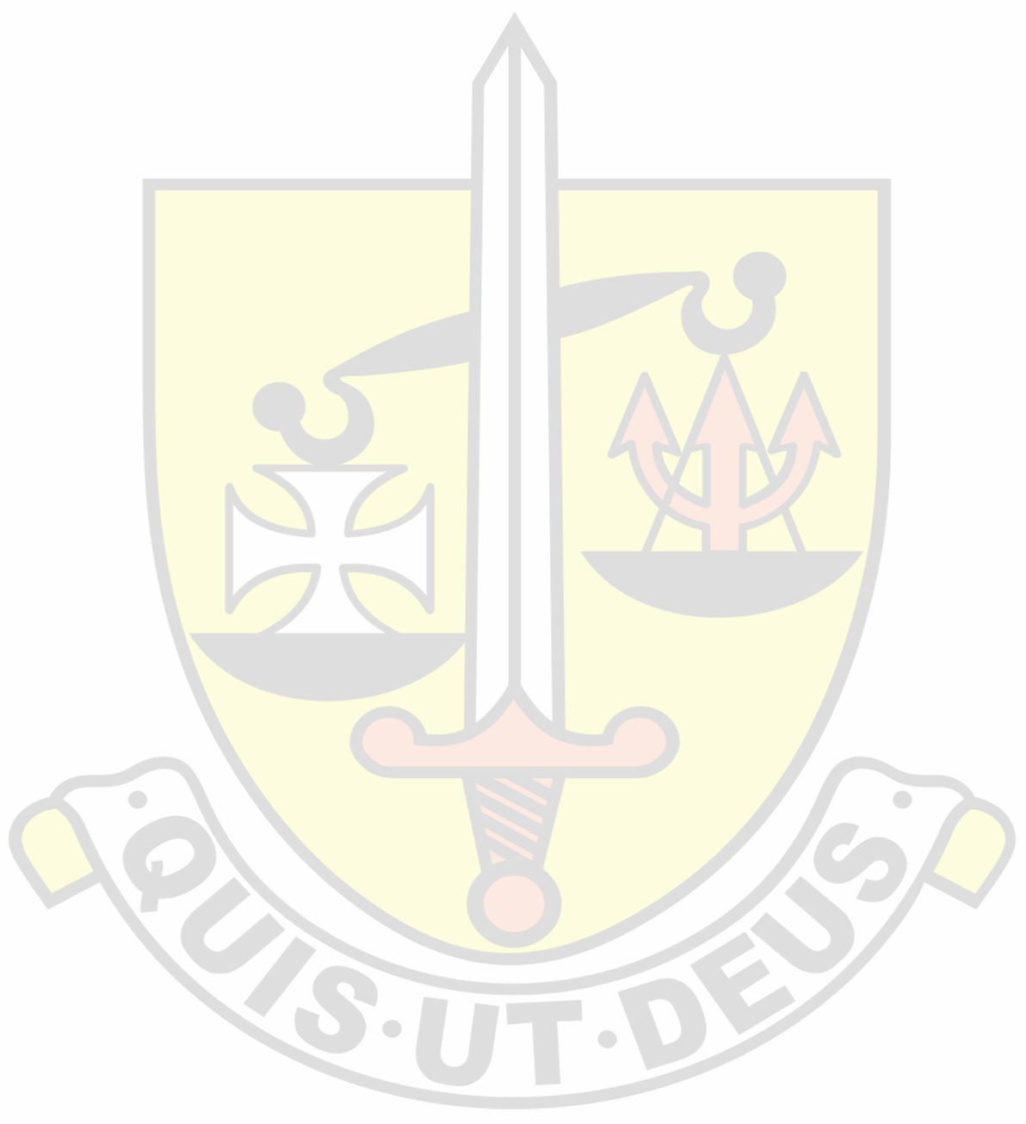

This booklet is to help you with your choice of subjects for G.C.S.E. It cannot tell you everything about a subject, but it will provide you with useful information about the content of the specification, the nature of the coursework, and the form of the final examination.

It will be necessary for you to undertake a good deal of further consultation and research before making your decision. You should consult your subject teachers concerning the ability you are developing in a particular subject. Your parents, of course, will be involved in this consultation too, at the parent/teacher meeting**.** You need to take into account your ability in each subject, the pleasure and satisfaction you derive from its study, and its relevance to your choice of career.

The National Curriculum for Years 10 and 11 (known as Key Stage 4) ensures that every student has a broad and balanced course of study, which fulfils the requirements of The National Curriculum.

Consequently:-

1. All pupils will study Religious Education, English Language and English Literature, and Mathematics.

2. Every pupil will study the three sciences - Physics, Chemistry and Biology in a co-ordinated course leading to two GCSEs in Science (Combined Science). It is also possible to opt for “Separate Sciences” – by doing so pupils will end up with three separate GCSEs in Biology, Chemistry and Physics.

3. In addition, every pupil will choose four subjects from the following list: Art, Computer Science Design and Technology, Drama, Food and Nutrition, French, Geography, History, Italian, Latin, Music. PE, Separate Science and Spanish.

This means that all our students study for 10 GCSEs.

The school currently offers French, Spanish and Italian at Key Stage 4. The school strongly recommends that girls choose at least one modern foreign language, although it is not compulsory. Girls are free to choose a language or combination of languages in line with their preferences and strengths.

We will do our best to give every girl her choices but some problems may arise from conflicting choices as well as from the possibility that too many girls may opt for a particular subject, making the group/groups oversubscribed. In addition, too few may opt for a subject – making the group too small to run. Unfortunately, resources are never unlimited. For this reason, pupils are asked to put their options in order of preference, and to choose six, so that we can respond to the strength of preference. The school then uses this order of preference to create options blocks and if certain combinations of subjects do not work then students are given their reserve choices. We do our best to maximise the number of students who get their top four choices – but we cannot guarantee that all combinations of subjects are possible.

In addition, all girls will study core PE and Education for Living including Citizenship, although these subjects are not examined.

You will be asked to list your choices on a form which must be signed also by your parents. It is necessary to make decisions this term because the school must plan the courses and the staffing for next year, and your choices may affect these plans. For this reason, a change of mind later may not be possible. You will have an appointment with a senior member of staff this term to discuss your proposed programme of study.

The procedure which is followed when a GCSE option group is oversubscribed is as follows:

Where there are too many pupils wishing to study a subject as first choice for the number of groups/teachers available:-

1) The Head of Department will place all the pupils who have opted for the subject as first choice in order of their:

* attainment ) in that subject
* commitment ) during Yr 9

2) Places on the course will be awarded strictly according to this order of precedence except in the case of a pupil who has Additional Educational Needs because she has experienced difficulties across a range of academic subjects which would otherwise endanger her chances of achieving a minimum level of success at GCSE. Pupils in this category will be given priority over those identified in No. 1.

3) When the group is full, a waiting list will be formed according to that order

and if a pupil drops out, the next child on the list will be given the place. The pupils not placed will be given one of their other choices.

4) A parent who is dissatisfied may complain to the Headteacher.

5) Appeals may be made to the Curriculum Complaints Committee of the Governing Body.

Finally, a word about the subject(s) you will no longer be studying after Year 9. Do not think of it as "dropping" a subject; you will no longer receive formal lessons, but your education continues and knowledge is never wasted. Make the most of the summer term lessons in that subject and aim to achieve a good result in the end of year exams in ALL your subjects.

Good luck in the task that now lies ahead!

**Mr. M. Stimpson,**

**Headteacher**

**The St Michael’s Curriculum at KS4**

At St Michael’s, we provide our students with a curriculum which is suitable for them, which enables them to open doors to career pathways in the future and which provides them with a broad and balanced range of subjects. Undeniably, GCSEs are part of a career pathway – but we recognise that the learning process is not about gaining paper qualifications, it is about enriching our lives and providing an education in the wider sense.

As a relatively small secondary school, we are not able to provide all possible subjects at GCSE, however, our GCSE offer is surprisingly wide considering our size. Our curriculum is not static – over time it responds to the requests, interests and preferences of our students.

As a Catholic school, the Bishops of England and Wales require us to enable our students to study for a GCSE in Religious Education (with Catholic content). Our Catholic faith is central to our life as a school and therefore central to our curriculum at GCSE with all students taking the GCSE and the results are amongst the best of any subject in the school.

All of our students are able – they achieved their place at this fully selective school by competitive entry and all are capable of going on to A Levels and securing places in the most prestigious universities and on the most challenging courses – for this reason we provide an academic curriculum offer to all our students. In addition, we provide creative, technological and artistic options at GCSE as we recognise that all our students are individuals and some will follow their interests and abilities in subjects other than the purely academic.

Our curriculum offer is an academic one - the compulsory subjects all students study for GCSE ensures this. In addition, students are encouraged to choose those options which relate to their interests and which facilitate their future career aspirations.

A number of years ago, the government introduced a measure called the English Baccalaureate (EBacc.), this is not a qualification (unlike the European Baccalaureate), but simply a measure of how academic the range of GCSEs are that are taken by students at GCSE. It is a measure of a school rather than an individual student. The EBacc. is not compulsory, nevertheless, the government hopes that in the future 75% of all students in the country will follow courses which ‘qualify’ for the EBacc. In response to this measure, some schools force their students to study only subjects which qualify for this measure – for example by ensuring that all students study either History or Geography and all students study a language. At St Michael’s we do not require this – the governors have decided that to do so would result in an unnecessary restriction on student choice and students would be denied access to some GCSEs that they would rather study. In addition, this would restrict access to the range of creative, technological and artistic subjects that currently exist, potentially stopping them running due to low numbers – and so restricting our curriculum offer.

We find that most of our students do choose subjects which qualify for the EBacc., numbers are in excess of the government’s target. As a school which puts emphasis upon supporting the individual, we feel that enabling our students to have a free choice for their options sits well with our ethos.

**Religious Studies**

Religious Studies has a special status within the 14-19 curriculum and is a statutory subject at Key Stage 4. At St. Michael’s it forms part of the core curriculum and is studied by all Year 10 and Year 11 girls to GCSE level. Students begin work on GCSE Religious Studies towards the end of the Spring term of Year 9.

We hope that the knowledge you gain will nourish and strengthen your faith, equipping you with the right attitudes and skills such as research, analysis, logic, reasoning, evaluation and creativity. These will assist you in your future years to make decisions of moral importance and have a wealth of information and knowledge at your disposal.

Content of the Course

This syllabus is set by AQA GCSE Religious Studies Specification B.

This includes the study of **Catholic Christianity** (Religion 1 50%), a study of **Judaism** (Religion 2A 25%) and the study of **St. Mark’s Gospel** (Religion 2B 25%).

**St. Mark’s Gospel**

Theme D: St Mark’s Gospel – the life of Jesus

* The early ministry of Jesus
* The later ministry of Jesus
* The final days in Jerusalem

Theme E: St Mark’s Gospel as a source of spiritual truth

* The Kingdom of God
* Jesus’ relationship with those disregarded by society
* Faith and Discipleship

**Catholic Christianity**

Catholic beliefs, teachings, practices, sources of authority and forms of expression in relation to six topics:

* Creation
* Incarnation
* The Triune God
* Redemption
* Church
* Eschatology

**Perspectives on Faith: Judaism**

* Beliefs and Teachings
* Practices

Exams are taken at the end of Year 11.

Assessment is by two written exams of 1 hour and 45 minutes each.

**English Language and English Literature**

During the course of the two years you will develop your skills as a discerning and perceptive reader as well as an accomplished writer who can adapt your prose style for different purposes whether it be to instruct, describe, inform or entertain.

The Literature component offers a broad and rich curriculum which includes study of modern and pre-1900 texts as well as there being on offer a lively poetry anthology with a range of poems from contemporary performance poets like John Agard and Carol Ann Duffy to more classical poets like Wilfred Owen and Shakespeare. Moreover, you may be offered opportunities to attend study days or theatre productions, which compliment study of set texts.

There is a KS4 reading list and opportunities for those wishing to extend their reading and writing repertoire. In addition, students can opt to attend Debate Club which develops their skills for speaking and listening.

English is a very popular subject at GCSE and many of our students consider it a stepping stone to A-Level. An outline of the components is set out below.

From 2015 students follow the new orders for AQA, Codes 8700 and 8702.

**English Language**

The course compromises of three components.

Paper 1: Explorations in Creative Reading and Writing

Students are prepared to be tested in *reading* one literature fiction text and *write* one piece of descriptive or narrative writing.

Paper 2: Writers’ viewpoints and perspectives. There are two sections in which students are assessed in *reading* (non-fiction and literary non-fiction texts) as well as *writing* where they will be expected to present a viewpoint.

There is a third component that is Non-examination Assessment: *Spoken Language* in which pupils present a talk, respond to questions and feedback.

**English Literature**

The course compromises of two components. Students are prepared to be tested in a range of literary genres:

Paper 1: Shakespeare (currently ***Macbeth***) and the 19th –century novel (currently ***Pride and Prejudice)***

Paper 2: Modern texts (currently ***An Inspector Calls***) and Poetry. This paper also includes a section C question (analysing an unseen poetry text and then comparing with a second unseen poem).

***All assessments are closed book: any stimulus materials required will be provided as part of the assessment. All assessments are compulsory.***

**Mathematics**

In Years 10 and 11 you will have to study Mathematics. This is an interesting and rewarding subject and many careers now demand a very good grade in this subject. Therefore, it is important that you reach your potential and attain the highest grade possible at GCSE.

As part of the course you will develop the mathematical skills and understanding required for the study of other subjects, for further mathematical studies and for adult life. You will revise facts, practise techniques and develop concepts. In particular, you will have the opportunity to:

* extend your knowledge of algebra and problem solving techniques
* build on practical experience of topics such as loci, probability and statistics
* develop mathematical applications to real situations, using arithmetical and graphical skills
* practise the use of trigonometry in relation to solids and three dimensions
* gain confidence and enjoyment from mathematical study.

The course followed is the AQA GCSE syllabus. All pupils at St Michael’s are capable mathematicians and all sets are aiming for the higher tier of entry with all grades available.

Whichever set you are in, it is important that you work positively and always persevere. Don’t forget to use the opportunities to see your teacher at lunchtimes if the need arises. The more you put into the subject, the greater the sense of satisfaction you will get and the higher your grade will be in the GCSE examination.

Hopefully you will also choose to study Mathematics at A level - it’s an interesting subject. Your teachers will tell you more about this in Years 10 and 11.

**GCSE Sciences**

**GCSE Sciences**

**All students will study either GCSE Combined Science (two GCSE’s) or Triple Science (three GCSE’s)**

GCSE Combined Science (GCSE Double Award)

(6 periods per week, two periods each week per subject – 2x GCSEs awarded)

Students may opt to study GCSE Triple Science (GCSE Biology, GCSE Chemistry, GCSE Physics)

(9 periods per week, 3 periods each week per subject 3x separate GCSEs awarded)

Our science courses are resourced with stimulating materials and include student practicals, teacher demonstrations, use of ICT in learning and a mix of other teacher led activities.

**GCSE Combined Science (equivalent to two GCSE’s)**

Students studying Combined Science will cover Biology, Chemistry and Physics topics with different specialist teachers.

Practical work is an essential part of the course. Many experiments are part of the required exam specification and will be included in the exams.

Topics covered include the following-

|  |  |  |
| --- | --- | --- |
| **Biology** | **Chemistry** | **Physics** |
| Cell biology | Atomic structure | Forces and motion |
| Health, disease and medicines | The periodic table | Energy and power |
| Photosynthesis & Ecology | Acids and neutralisation | Waves |
| Natural selection and evolution | Electrolysis | Electricity and circuits |
| Genetics | The atmosphere | Magnetism and electromagnetism |
| Hormones & control | Reversible reactions | Radioactivity |

**Assessment**

There will be two exams in each subject: Biology, Chemistry, Physics (6 total regardless of option).

Each exam- I hour 10 minutes (triple) [45 mins (combined)]. All of the exams are sat at the end of Year 11.

Each exam contributes 16.6% of the overall GCSE result

Question types: Multiple choice, short answer questions and longer written response questions.

There is no assessed coursework in this course.

**Art and Design GCSE (OCR)**

**Why take GCSE Art and Design?**

Art and Design GCSE is an essential subject to take if you are considering a career in the art world e.g. architecture, design (textiles, fashion, graphics, theatre), game design, animation, photography, advertising, media, film. Equally, if you want to follow a career where you need to be dextrous e.g. dentistry, medicine (a surgeon). Or if you want to be an artist. Art equally is a subject that complements other subjects well, we encourage students to discuss and debate, present ideas and share their knowledge and understanding of the world about us in relation to the art we are looking at.

**Course structure**

60% coursework/portfolio

40% ESA (Externally Set Assignment or exam).

**Coursework** takes the form of a portfolio of work that the students develop over the whole course. Lessons, which are highly structured, allow students to develop the skills required to ultimately create a very individual body of work. We help students to expand their skills and techniques involving drawing, painting, textiles and 3D process including clay. Equally we want students to develop their knowledge and experience of art, studying individual artists, whole movements and different cultures. We are increasingly looking at contemporary art and the issues related to them.

**The ESA** runs in spring term of yr11 when the students are given themes set by the exam board (OCR) to develop their own ideas and techniques from, this is all under the supervision of the art teacher. After a period of 8 weeks, students are then given 10hrs over 2 days to create their final piece of art and present it for assessment.

We want students to be experimental with techniques and ideas, being prepared to take risks with their work so they can achieve their full potential.

We organise trips to museums and galleries to experience art first hand and have worked with artists directly. We encourage students to go to see art work themselves in their own time so becoming independent workers.

The course is stimulating and enjoyable and the standard of work is high. Past students have gone on to study A level art and go on to art college, we now have old girls designing for Reiss in NYC and helping to run the White Cube Gallery in London.  Plus past GCSE art student Katy Hessel is an art historian, broadcaster, writer and curator. She has recently published her book ‘The History of Art without Men.’

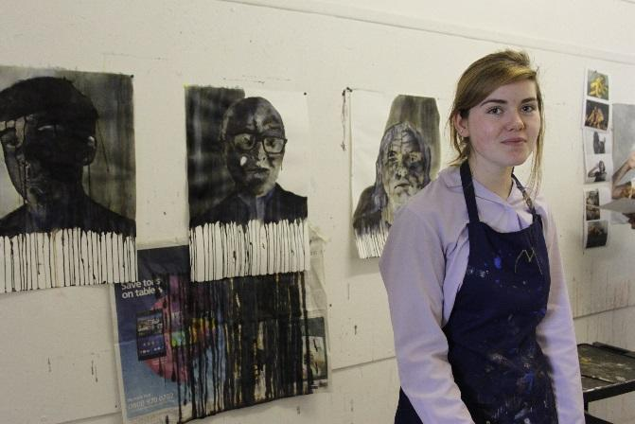

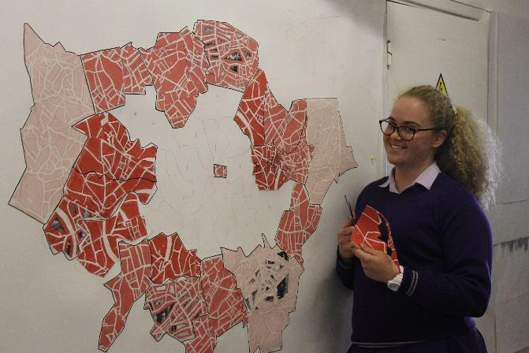

**GCSE Computer Science (OCR)**

**Why take Computer Science as a GCSE?**

Computer Science GCSE provides opportunities to work with a variety of technologies. The course is designed to allow you to be digitally literate, with an up-to-date understanding of the digital world around you. It is a modern, fascinating subject!

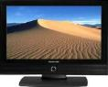

You will explore practical applications of programming languages and study a range of creative programming applications in order to create a working problem to solve a given task. You will develop an awareness of how to analyse a problem as well as the steps needed to design, develop, test and evaluate a working solution to a real-life situation.

**Course structure (OCR – exam board):**

The course is assessed through 100% examinations. Students will study 2 units which are equally weighed (50%) and will be undertaking the exams at the end of year 11. Each exam is an hour and ½.

**Unit 1 – Computer systems:**

This unit covers; systems architecture; memory; storage; data representation; wired and wireless networks; network topologies and protocols; system security and systems software.

**Unit 2 – Computational thinking, algorithms and programming:**

This unit covers; algorithms; programming techniques; producing robust programs; computational logic; translators and facilities of languages. Additionally, this unit involves using a variety of programming languages to design, develop, test and evaluate code in different scenarios.

**Career prospects:**

GCSE Computer Science opens up an incredible world of opportunities in technology. The course is designed to enhance lots of transferable skills in all industries such as logical thinking, problem solving, creativity, data analysis and lateral thinking. All skills being picked up whilst studying Computer Science could be useful for a whole bunch of careers. If you want a career in Computing, jobs options are endless however here are some listed for you:

* Computer Programming
* Software engineering
* Website/app/design development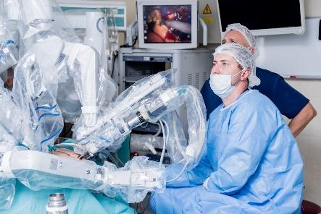
* Computer game development
* Teaching
* Cybersecurity
* Forensic computer analyst
* Computer technician

If you have any questions in regards to this subject, please contact Miss Ordu.

**GCSE Design and Technology (AQA)**

Studying Design Technology leads to careers such as; Product Design, Engineering, Architecture, Graphic Design, Set Design, Industrial Design, CAD Design, Marketing and Branding to name but a few.  It is unique in that you emulate the actual work of a designer in working with a real person, known as your client.  You will be guaranteed a small class, maximum of sixteen students, which really gives you a chance to pursue areas of interest.

What is Design and Technology?

This GCSE builds on the foundation skills gained throughout KS3, whilst enabling you to tailor elements of it and draw on other subjects you enjoy. You will develop design and thinking skills that open up a world of possibility, giving you the tools to produce high standard products.  It hones problem solving: drawing on Science, Maths, Art and Computer Science skills. You will be solving a range of practical problems by:

* Identify real life needs and eventually working with a real life client
* Critical thinking with a chance to apply skills and knowledge from other subjects
* Using design innovation to create solutions to benefit people and the planet
* Experimentation through modeling, CAD and traditional varieties
* Making to a high skill level an imaginative functioning prototype
* Consider commercial viability, marketing and costs

**Course Details**:

*1.  Year Ten - is skills and theory based teaching, with a number of mini projects*

*2. Year Eleven - Coursework project - A practical project based on your choice from the exam boards selected themes. (50%)*

*3. Exam – One 2 hour exam paper (50%)*

**Design and Technology:**

* Communication of ideas through sketching and working drawings, design development and modeling.
* Working as a designer to solve a variety of problems.
* Knowledge of the properties and construction methods of: timbers, polymers and modern/smart materials. You will get hands-on experience of a vast range of techniques through mini projects.
* Become much more familiar with the designed world by being able to identify and suggest uses for commercial manufacturing processes.
* Knowledge of structures, mechanisms and motion, which can be through card engineering of pop ups and structures, to creating automata with cams.
* Work to your strengths and area of interest with a choice of coursework projects.

Remember if it cannot be found in nature it has to be designed, this subject touches so many areas of our lives, and gives you the chance to influence the future.

**GCSE Drama**

**Exam Board- AQA**

The most important part of GCSE Drama is creating and acting in live performances. These performances will be scripted and devised and you will perform in a variety of performance styles. You will also be expected to take on the role of the director both in class work and your written exam. During the course you will study play texts from the perspective of an actor and a director. There will be visits to live performances and you will need to evaluate the effectiveness of these performances. 

The course comes in three parts-

1. **Written Exam-** The written exam comprises three sections where you will be expected to;
2. Show an understanding of Drama and Theatre terminology
3. Show directorial understanding of a given extract of a set play.
4. Evaluate a live theatre production you have seen.

This is worth 40% of your final mark.

1. **Devising Drama-** You are assessed on your understanding of the process of devising drama and your contribution as a performer.

This is 40% of your final mark.

1. **Text in practice-** A performance of two extracts from one play. This is worth 20% of your final mark.

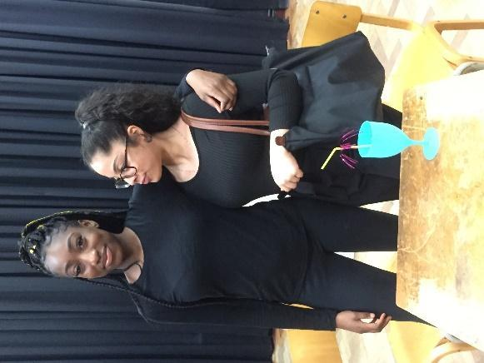

It is essential in drama that you can work well in a group and are committed to the subject. Your group may need you to rehearse at lunchtimes or before or after school. Drama skills are useful in a variety of careers and presentation and communication skills are vital whichever path you decide to take.

**Questions?**

If you have any further questions, please ask Ms. Baron and she will be happy to help!

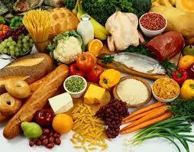**GCSE Food and Nutrition**

Food and Nutrition builds a range of skills and knowledge:

* Food, nutrition and health
* Food science
* Food safety
* Food choice
* Food provenance

There is an emphasis on practical work; lessons build skills and offer creative opportunities.

If you have enjoyed KS3 Food and Nutrition and have a flair for practical work and an interest in diet, health and nutrition, then this could be the subject for you.

**Course Details:** AQA Board

|  |
| --- |
| * Written exam: 1 hour 45 minutes * 50% of GCSE * Non-exam assessment (NEA) - Practical ‘coursework’:   **Task 1:** Food investigation This is undertaken in Y11 during lesson time and tests students' understanding of the working characteristics, functional and chemical properties of ingredients.  **Task 2**: Food preparation assessment Also in Y11 lesson time; students research a given topic, prepare, cook and present a menu of three dishes within a single period of no more than three hours, planning in advance how this will be achieved.  Future Possibilities:   * There are many opportunities in the food industry (the largest UK employer) eg. recipe development, journalism, food photography, catering and product design. * The subject provides a foundation for careers in medicine and related fields eg. general practice, physiotherapy, occupational therapy, psychotherapy, dietetics, nursing and food science. * Teaching. * In previous years girls with GCSE Food and Nutrition have gone on to read Law at Oxford; Classics at Cambridge and others are pursuing careers in teaching, forensics, geography and business. |

**GCSE Geography – A sense of place about the world around you**

**Geography – the world around you**

• learning more about the world we live in and contemporary issues – climate change, globalisation the impact of technology on our leisure and work.

• developing skills that will help you in other areas, such as IT and research

• completing your own practical field work away from the classroom

• working in a team with other students

• learning through investigating and doing, as well as listening and reading

...all these make GCSE Geography is the ideal subject for you.

Students gathering data on river flow

**What do I need to know before taking Geography?**

You will have learned a number of geographical skills and gained a body of knowledge in Years 7, 8 and 9. This will be developed further during the GCSE course to give you a deeper understanding of the world. Much will be new but your previous study of geography will have prepared you and helped you to think like a geographer.

**What will I learn?**

The world is always changing. Geography gives you the chance to learn about these changes. There are three components in the Edexcel Geography A qualification:

|  |  |  |
| --- | --- | --- |
| Exam Board: Edexcel GCSE (9-1) Geography A (2016) Pearson qualifications | | |
| **Component 1:** **The Physical Environment**  **This unit is based on physical geography and you will need to study the following topics:**  Topic 1: The changing landscapes of the UK:   * Coastal landscapes * River landscape   Topic 2: Weather Hazards and Climate Change  Topic 3: Ecosystems, Biodiversity and Management  Assessment : 1hr 30 minutes exam | **Component 2**: **The Human Environment**  **This unit is based on human geography and you will study the following topics:**  Topic 4: Changing Cities  Topic 5: Global Development  Topic 6: Resource Management  Assessment : 1hr 30 minutes exam | **Component 3**: **Geographical investigations**  Topic 7: geographical investigations: Fieldwork – trips to urban locations and regeneration sites and physical geography sites (rivers and coasts) to gather fieldwork data  Topic 8: Geographical Investigations: UK Challenge.  Assessment: 1hr 30 minutes’ exam |

**How will I be assessed?**

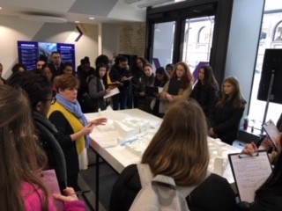

The course is linear. This means you will be examined at the

end of Year 11. You will take exams in Paper 1, 2 and 3 in

May/June.

**What can I do after I’ve completed the course?**

Geography is a fantastic subject *and* has numerous cross

curricular links to other subjects. A GCSE in Geography is a

stepping stone to a whole range of opportunities. The skills you

develop can lead you to employment opportunities in

journalism, media, engineering, IT, travel and tourism,

environmental management, marketing, business management

and teaching. As geographers learn about human and

Students gathering data on the

Kings Cross regeneration

population development, geography can be useful for jobs

in charity and international relations too.

**GCSE History**

People study History because it is interesting and they enjoy it. That is why museums are so popular, and why so many people read history books or fiction set in the past. We are fascinated by the wonders and tragedies of human behaviour and an understanding of History deepens our understanding of human behaviour.

Of course there is more to the subject than simply enjoying it. History helps us to develop many skills which we need later in life. It helps us to understand why people acted the way they did. It enables us to be critical in our thinking, to analyse and evaluate situations, and to express our ideas in a clear and logical way. We can, through studying history, come to understand our own society and age more clearly, and see the effects of geography, economics and other influential factors on human behaviour.

History forms part of a good general education and Universities, Colleges and employers like to see it among a candidate's GCSE qualifications. Those who study History beyond GCSE find employment in all sorts of fields, either directly related like Teaching, Museum or Archive Work, Tour Guiding or Archaeology for example or indirectly related, such as Journalism, the Law, Politics, while other areas of employment such as Business Management, Accountancy or Banking are full of historians as well.

Current Year 9 pupils have been studying the National Curriculum History syllabus for Key Stage 3.  For GCSE the History Department follow the history syllabus which is set by the **EDEXCEL** board.  We intend to visit Berlin as part of our studies of Germany and the Cold War.

The course covers four main areas of study:

1) Weimar and Nazi Germany 1918 – 1939

2) The Cold War 1943 – 1991

3) The History of Crime in Britain through Time 1000 till the present day

4) Early Elizabethan England 1558 – 1588

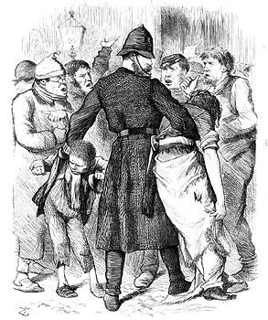The 4 examinable topics are examined in external exams at the end of the course. There is no coursework. The exams test pupils’ detailed knowledge of the topics, their ability to critically assess the value of fragments of historical evidence and to assess the merits of divergent interpretations of history. Pupils will be graded Grade 1 to Grade 9 (highest) according to the GCSE grades introduced in 2016.

**GCSE Latin**

**Why should I study Latin for GCSE?**

There are several **very good reasons**:

**I.** You have been studying the language for two years now and you have acquired a great deal of vocabulary and linguistic knowledge, much of which is in the current Latin syllabus for GCSE.  Why not put all that knowledge to good use?

**II.** Your knowledge of **English and other Modern Languages** will be **enriched** as you discover the roots of words and how languages actually work.

**III.** It will help you decipher **medical** and **legal** terms, words used in **politics** and new **technical** vocabulary.

**IV.** You will be introduced to some fascinating stories from **Greek and Roman mythology**: The Twelve Labours of Hercules, Hades’ abduction of Persephone, Romulus and Remus to name a few.

**V.** Ever wondered what the Romans really liked to do in their free time (apart from seeing blood spilt in the arena) or exactly why women got the worst seats at the theatre? You will discover the answers to these questions and gain a more in-depth understanding of **Roman Civilisation**.

**VI.** You will have the opportunity to experience the art, culture and architecture and of the ancient Romans first hand during the Classics department trip to **Pompeii** in Year 11.

**VII.** Think of Latin as ‘brain-training’:  you will develop your skills in analysis, logic, problem-solving, pattern-spotting and developing your memory. These are skills that are useful to **everyone.**

**Course structure and content**

* There are **three** units which will **all** be examined at the end of Year 11.
* There is a **defined vocabulary list** for the language paper totalling **440 words** (this can be found on the EDUQAS and Cambridge Schools Classics Project websites).

|  |  |
| --- | --- |
| **Year 10** | **Year 11** |
| **Paper 1: Latin Language**: comprehension, translation, English into Latin and word derivations. | The study of **Latin Language** is continued in Y11, broadening knowledge of grammar and vocabulary and developing fluency in translation through reading some great stories! |
| **Paper 3: Roman Civilisation:** Roman Family Life: this unit investigates the archaeology of social and domestic life in the Roman era as well as delving into the rights and duties of citizens. | **Paper 2: Latin Literature and Sources:** We will explore Love and Marriage in the Roman World, through letters, artworks and superb literature in the original Latin. |

**Can it help with career choices?**

* The complex nature of Latin means that a person who has studied the language stands out amongst other candidates as someone who has well developed intellectual and analytical capabilities. It is very well regarded by universities.
* Students of Latin go on to be successful in all sorts of careers, such as law, IT, banking, publishing, writing, media, politics, and the civil service. The list of possible careers is very long!
* In recent years we have found that a familiarity with Cicero’s speeches and the legal system of Rome has contributed to successful applications for the study of Law at Oxford and Cambridge.

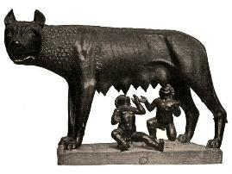 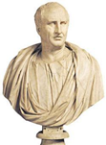

**Modern Foreign Languages**

*“If the UK is to engage fully with the wider world in business, diplomacy and academia we need more young people studying languages.”* Dr Wendy Piatt, Director General of the Russell Group, 2015



**At St. Michael's you have the chance to study one or two of the 3 languages offered:** French, Italian and Spanish.  
All follow the AQA syllabus.

The overriding objective of studying at least one Modern Foreign Language is to equip you with the language skills and cultural knowledge necessary for you to play a full and active role in a world that is becoming increasingly international.

**Exciting curriculum and opportunities**

Studying languages at GCSE provides challenge, intellectual stimulation and enjoyment and will offer you invaluable insights into the cultures of other countries. Even more exciting, during the 2 year course, we really hope you will be able to be part of wonderfully exciting exchanges and trips!

**Skills**

Studying at least a foreign language at GCSE shows a real breadth of knowledge and develops communication and critical thinking skills, which are readily transferable and highly sought-after in further education and employment. This is why Modern Foreign Languages are considered as ‘facilitating’ subjects by the Russell Group universities (top 24 universities including Cambridge and Oxford).

**Now…what to expect in the next two years of your MFL GCSE(s)?**

**The syllabus**  
The new **Spanish** and **French** syllabuses are divided into 3 core themes:

* Theme 1- People and lifestyle: Identity and relationships with others, healthy living and lifestyle, education and work.
* Theme 2- Popular culture: Free-time activities, customs, festivals and celebrations, celebrity culture.
* Theme 3- Communication and the world around us: Travel and tourism, including places of interest, media and technology, the environment and where people live.

The current **Italian** syllabus is divided into 3 core themes:

* Theme 1 - Identity and culture: Me, family and friends, technology in everyday life, free time activities.
* Theme 2 - Local, national, international and global areas of interest: Home, town, neighbourhood and region, social issues and global issues.
* Theme 3 - Current and future study and employment: My studies, life at school, education post-16 and job, career choices and ambitions.

**Assessment**  
You will be assessed in four skills through four papers – Listening, Speaking, Reading and Writing.  Each component accounts for 25% of the exam. All the exams are linear so they will take place at the end of Y11. You will work towards the Higher Level tests.

**GCSE Music (Eduqas)**

GCSE Music is both an academically rewarding course and one which deepens students’ enjoyment and curiosity about music. In particular, students can expect to develop their skills in performing, composing, and appraising/analysing music. If you play an instrument and/or sing, and are interested in learning more about music, this could be the course for you. There is 60% coursework, which will take some pressure off when you come to your GCSE exams.

**COURSE OUTLINE** - The course has 3 components:

|  |  |  |
| --- | --- | --- |
| Performing  30% | One ensemble piece and one piece linked to an Area of Study.. | Coursework |
| Composing  30% | Two compositions, completed during the course, using Sibelius or GarageBand. | Coursework |
| Appraising  40% | 8 questions, 2 on each area of study:  AoS 1 Musical Forms and Devices (including a set work)  AoS 2 Music for Ensemble  AoS 3 Film Music  AoS 4 Popular Music (including a set work) | 1 exam at the end of Year 11 |

This examination will assess knowledge and understanding of music through the following four areas of study:

Area of study 1: Musical Forms and Devices   
Area of study 2: Music for Ensemble

Area of study 3: Film Music

Area of study 4: Popular Music   
  
GCSE Music lessons are practical, and students are expected to use their instruments/voice both to perform, and to come up with ideas for composition. There will be regular opportunities to practise performing as a soloist in lessons. GCSE students also have access to the iMac suite during and outside of lesson time to work on composition. Wider Listening is very important for GCSE Music, and students are encouraged to go to concerts and listen to a broad range of music. Most recently, Year 10 and 11 GCSE Music students have been to see *Wicked* in the West End and there are more trips on the horizon.

**REQUIREMENTS**

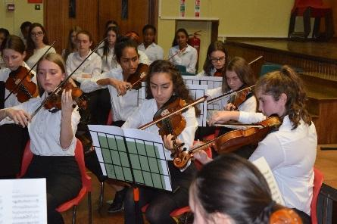You do not need to have done formal practical or theory exams to take GCSE Music, though most students will have done some. You will need to be playing pieces of around Grade 5 standard in Year 11 to achieve the highest grades – do not worry if you are not at that standard yet. Students can sing or play an instrument for their performances, and all students taking GCSE music must be having weekly instrumental/vocal lessons with a specialist teacher – these do not need to be taken in school, though many students do study an instrument here. The school may be able to offer support with meeting the costs of music tuition in cases of financial difficulty – please contact Mr Pearce or Mrs Sheehy in confidence for more information. If you play or sing music to Grade 4/5 standard and beyond already you would go into the course with an advantage.A basic understanding of the theory of music is advantageous for students starting the course, and the department offers lunchtime lessons in Grade 5 Theory to support students who are less experienced in this area.All students at GCSE level must attend one lunchtime ensemble of their choice, choosing from Choir, Orchestra, or Jazz Band. However, many students attend multiple ensembles. There are regular performances, including at concerts, masses and the Carol Service, in which GCSE students are expected to participate. There is also the opportunity to take part in concert tours abroad.

**PROGRESSION AND CAREERS**

GCSE Music is ideal preparation for the future study of music, such as A level Music or A Level Music Technology, and is usually required by anyone wishing to pursue a musical career. Within music, possible careers include arranging, composing, recording and performing in a wide variety of contexts. It is also helpful for those hoping to be involved in education, music therapy, dance, theatre, radio, television, music administration and the recording industry. The course also provides students with wider-reaching skills of analysis, creativity, independent working and co-operation with others. *If you have any questions about GCSE Music, please do speak to Mr Pearce or Mr Miller for more information*

**GCSE - PHYSICAL EDUCATION** 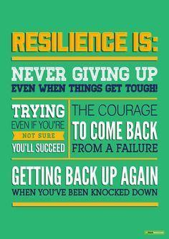

**Have you ever wondered...**

• Why some people are good at sports and others not?

• Why you are a great swimmer but hate running?

• How you could go from being a good athlete to being in the Olympics?

• Why people take drugs?

Study GCSE (9–1) Physical Education to find out the answers.



**How will you be assessed?**

• Non- Exam Assessment (NEA). Three practical performances (30%)

• NEA. One Performance Analysis task. (10%)

• A total of two hours and 30 minutes’ assessment split over two examination papers (2x 1.15 hour) taken at the end of the two-year course. (60%)

**Paper 1: The Human Body and Movement in Physical Activity and Sport**

Written Exam - Applied anatomy and physiology, Movement analysis, Physical training, Use of data.

**Paper 2: Socio-Cultural Influences and Well-Being in Physical Activity and Sport**

Written exam Sports psychology, socio-cultural influences, Health, Fitness and Well-being.

**What are the benefits?**

• This is an interesting and challenging learning experience. In it we introduce key sporting ideas and show how these interact with practical performance, you will gain insights into the relationships they have with each other throughout the course.

• The development of transferable skills including decision-making, psychological understanding of people, independent thinking, problem solving and analytical skills as well as thinking, acting and reacting under pressure.

• The study of AQA GCSE (9–1) Physical Education opens up a range of possibilities for further study and into careers associated with the subject. For those of you fascinated by the human mind, why not carry on to Psychology? For people who want to understand human behaviour through sport, this is an excellent pathway to Sociology and for those undertaking the sciences with the intention to move through into Medicine or Physiotherapy.

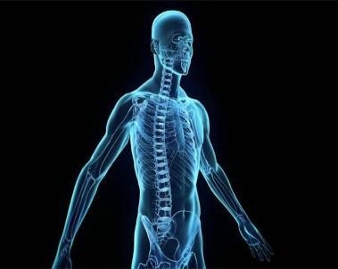

**REQUIREMENTS**

Students are expected to pursue at least one specialist sport regularly, outside of school sports at club level.

**GCSE Triple Science:  GCSE Biology, GCSE Chemistry, GCSE Physics**

This course involves all of the material covered in the GCSE Combined Science course with additional topics in each subject- Biology, Chemistry and Physics.

Topics covered only in the Triple Science course include-

|  |  |  |
| --- | --- | --- |
| **Biology** | **Chemistry** | **Physics** |
| The eye | Transition metals | Ultrasound and infrasound |
| DNA and protein synthesis | Chemical cells and fuel cells | Lenses |
| Plant diseases | Organic chemistry | Nuclear fission and nuclear fusion |
| Auxins | Chemical analysis | Astronomy |
| The kidneyhttps://lh6.googleusercontent.com/yYHWhylrUcr_jdu8MB9ILBx6NIG89NqUi32dloXYKnaSKBGzvj9EcebpI3IYjDyeLYO17QjmgOSfxgYI5F-Jz9Q4SPt3sAEpI60TPT2qRKc9bp1y4Kz9OwGbVWsc2g | Nanoparticleshttps://lh4.googleusercontent.com/xBG-1hj4ujxkQRawLUUUF-0cUa7vgZMHYCLOtEUGK5jd4q4UbJixfShc_vAf9pGuYga7vsPTc5H3vrasJFCj63AVqSPhzsKPJLcokDDgCKrBdyOheUnAO69HXnJEcg | Static electricityhttps://lh6.googleusercontent.com/8Mth7f9WdPArCQ_VqCkM2r40kjVrjd82t7v1zWIxccR7Ehg96qAmA873HW2XrQOyCAKTgA4yeTMsJ04AtJxZiONkOgEu7xax3lsYN5G8DOZ9zYEhPpq4G8flJlIgeg |

**Assessment**

There will be two exams in each subject: Biology, Chemistry, and Physics.

Each exam- I hour 45 minutes (100 marks).  All of the exams are sat at the end of Year 11.

Each exam contributes 50% of the assessment of each GCSE science subject.

Question types: Multiple choice, short answer questions and longer written response questions.

There is no assessed coursework in this course.

**Why study Triple Science?**

Triple science gives young people the opportunity to go into further depth with their scientific studies, and to study some topics that aren’t present in the core GCSE Science qualification.

Candidates who do not study Triple science are very much able to study A-Levels (and even degrees) in scientific subjects, so in this respect, Triple Science is ***not a requirement*** of future scientific study. This being said, candidates who take Triple Science do find the transition to A-Level easier.

In summary, Triple Science is the ideal course for the curious and those who can’t get enough scientific study in their daily lives.

**Pastoral Curriculum**

The Pastoral Curriculum complements and supports the academic curriculum in all year groups.

The Pastoral Curriculum deals with aspects of the personal and social development of our students in a more planned and structured way than is possible when left to chance. Naturally most lessons in all the subjects on offer will involve areas of personal and social development. However, by organising a specific programme, we hope to ensure that every student, no matter what subject option she chooses, will have every opportunity to learn and discuss these aspects of education. The Pastoral Curriculum includes the Tutorial Programme followed with Form Tutors in each year, Citizenship, Economic Awareness, Critical Thinking and Communication skills in Year 7, Education for Living lessons in Years 7 - 10, as well as specially arranged events throughout the years. The topics we cover include RSE, communication skills, decision making, leadership, health education, study skills, economic and industrial awareness, understanding the world of work, understanding of local and central government, careers guidance and counselling - to name but a few!

### **Progress File**

The materials covered within the Pastoral Curriculum are kept in each girl’s Pastoral folder which is equivalent to a Progress File. This will become a positive record of all you have achieved during your time at St. Michael’s.

What will be in it?

1. All your Pastoral resources including Tutorial work, Citizenship, Education for Living and Work related preparation.

2. Evaluation sheets such as a Citizenship log which will help you keep track of your achievements.

3. Personal Statement word processed by you, which outlines the courses you followed, where you express your own general attitude and opinions on how you feel that you have developed over the past few years. Your statement will include academic and non-academic achievements.

4. Wider achievements e.g. Duke of Edinburgh, work experience, school clubs, sporting achievements.

5. Action Plan – how you see your ‘career’ progressing. You will also receive literature from the Careers service, which will help you plan for Higher Education and ultimately a career.

You are already working to complete your Progress File whenever you have a Pastoral session or when you complete any form of self-assessment. You will write your Personal Statement with help from your form tutors. This will be a summary of your learning experiences, your qualities and skills, interests and future hopes. You will be helped with your self-assessment in Tutorial lessons. In Year 10 you save your personal statement on the computer system so you can then update it in Years 11 – 13.

We feel that the Pastoral Curriculum is a very important part of the education of our girls and also acts to support and enhance the academic curriculum we offer.

Our aim is to prepare St. Michael's students as fully as possible for life as young women in today's world - to equip them with the necessary personal and social skills to use in both adolescence and adult life.

**WORK EXPERIENCE**

All girls in Year 10 are involved in two weeks’ work experience, where a programme of activities/work is arranged for you in a place of work instead of coming to school. There is also the opportunity to take part in a variety of virtual work experience sessions. You do not get paid for this work!

**Why do you need to do it?**

Work experience is compulsory for all pupils at key stage 4 to help with your understanding of work related issues, a part of the National Curriculum. But, there are many reasons, and the main purposes of Year 10 work experience are: -

1. To build up your self-confidence.

2. To allow you to get to know yourself better - your strengths, weaknesses,

likes/dislikes.

3. To help with your GCSE studies.

4. To experience sensible decision making.

5. For you to show initiative in an environment other than school and home.

6. To co-operate with adults other than your parents and teachers.

7. To gain an insight into the disciplines of the world of work.

8. To show what you know and what skills you already have.

9. To learn new skills and approaches to novel situations.

**How is work experience organised?**

At present, Year 10 go out for their 2 weeks towards the end of the summer term, and you will be notified of the exact date well in advance.

You will be asked to see if you can find your own placement and then you will have to fill in an application form that has to be signed by your parents. The teachers in charge of work experience (Mrs Wallis and Miss Cheuk) will confirm your placement and work out all the details with you. When you are on your placement, you will be visited by a member of staff to review your progress and you and your employer will be asked to write about the experience. If you successfully complete your 2 week placement you will be awarded a certificate which outlines what you have done.

**How will you know what to do on your placement?**

During the course of the year your form tutors will be working through a pack of materials with you to prepare you for your work experience. The pack will not only include organisational details, but items for discussion and role play such as equal opportunities at work, health and safety, rules and responsibility. After the placement you will also be advised how to analyse your experience and learn from it. Any work and resources you are given must be kept in your pastoral folders, and you will be asked to keep a log book of your activities during your placement.

**How does work experience link with my other school work?**

There are links with both the pastoral curriculum (in tutorial and assembly times) and with your other subjects eg. ICT skills you may have learnt at school may be useful to you on your placement; or you may learn a skill that you can bring back and use at school; or you may bring back information that you can develop into coursework; you may be asked to write about events in English or do role play in Drama; you may be able to invite employers into school to help with coursework.

**Do I do work experience only once?**

Yes, as far as Year 10 is concerned, but Mrs. Wallis and Mr. P. Ward (Deputy Head of Sixth Form) are happy to help you arrange work experience in Years 11, 12 and 13 on an individual basis. In fact, it is advisable that you do try some extra work experience or work shadowing especially in Years 12 or 13. There is also the opportunity of doing work experience in Europe in Year 12.

**ST. MICHAEL’S CATHOLIC GRAMMAR SCHOOL**

**2025: Programme of Study for Years 10 and 11**

NAME (Block capitals please):

..........................................................................................................

FORM: ...................................

CHOICES:

***N.B. In order of preference***

1 .............................................................

Reserves:

2 ............................................................. 5 ....................................................................

3 ............................................................ 6 ....................................................................

4 ………………………………………………………...

PUPIL’S SIGNATURE .....................................…………………………………………………………....…

PARENT’S SIGNATURE.....................................................................................................

COUNTER-SIGNED BY ...................................................... DATE..................................................

SENIOR MEMBER OF STAFF