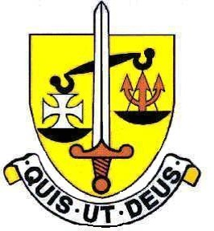
St Michael’s Catholic Grammar School
English Department

The English Department has six members of staff currently, some of whom are part-time.
The Department has allocated English classrooms, all located in the new building and equipped with the latest technology to aid teaching.
The Department uses the school’s Library to conduct library lessons for Year 7. Each student is expected to keep a reading journal and reading log. All KS3 and KS4 students are expected to bring a reading book to every English lesson.
Students are currently taught in form groups in years 7 and 8, and mixed groups of approximately 24 in Years 9-11. The Department currently has two A-Level teaching groups of approximately 15-18 students in each.
The department is committed to raising achievement at all levels and students are assessed at the end of each half term. Targets are set through CATs testing in Year 7 and ALIS in Year 12.
Curriculum is organised into units of work that reflect the secondary strategy and these are planned around central aspects of the National Curriculum. The units are regularly scrutinised to improve the pace and quality suitable for our academic intake.
At KS4 the Department teaches AQA English Language (8700) and English Literature (8702). Prose and Drama are taught from the range of fictional texts as outlined in the Specification. Poetry is delivered using the AQA Anthology.
Department results at GCSE are consistently good in both English Language and Literature. GCSE is regarded by our most passionate students as a precursor to studying English Literature at A Level.
At A Level we offer English Literature (AQA Specification A 7712) in Years 12 and 13. English Literature has a good uptake and a high success rate. The rigour and challenge of the A Level course result in our most passionate students progressing to Oxbridge and Russell Group universities.
The Department offers Oxbridge mentoring to aspiring A level students. In addition, all students can take advantage of a range of extra-curricular activities including Debate Club, Book Club, Poetry Club and Creative Writing Club.

May 2024

