ST. MICHAEL’S CATHOLIC GRAMMAR SCHOOL

Nether Street 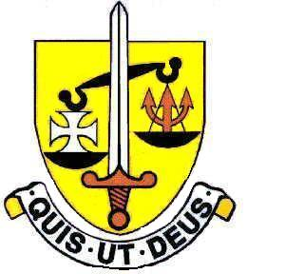 Voluntary Aided
North Finchley “An outstandingly effective School” Ofsted

London N12 7NJ
Tel: 020 8446 2256

Email: applications@st-michaels.barnet.sch.uk

4 Form Entry Voluntary Aided Grammar School for Girls with Boys in the Sixth Form
850 on Roll. 245 in Sixth Form.

Temporary Teacher of English & Drama
Salary – Main or Upper Scale

To start 1st January 2023 – required until February Half Term

The Governors are seeking to appoint an enthusiastic temporary Teacher of English & Drama to this selective school, four times judged OUTSTANDING by OFSTED, which is committed to the ideals of Catholic education and where GCSE and A Level results are consistently excellent.

This unexpected vacancy has come about through sickness absence of the current post holder. The successful candidate will teach KS3 and KS4 English and also KS3 Drama (there are separate Heads of English and Drama to support). Both experienced and beginning teachers will be considered who enjoy the challenge of teaching well-motivated and intelligent students whose behaviour is exemplary in this selective school. Expertise exists within Drama & English to provide high-quality support to an ECT or someone in the early stages of their career.

The English Rooms are in a new building and equipped with the latest technology to aid teaching.

The school provides a very rewarding working environment where employees are valued and there is a focus on staff welfare.

An application form, job description and departmental information are available on our website.

Please send completed applications to applications@st-michaels.barnet.sch.uk.

Closing date: Monday 12th December midday – interested applicants should contact the school as soon as possible as we reserve the right to call candidates to interview before this advert is withdrawn.

We are committed to safeguarding and promoting child welfare
The post is subject to an enhanced DBS check
St. Michael’s is an equal opportunities employer - applications are welcome from all sections of the community

