ST. MICHAEL’S CATHOLIC GRAMMAR SCHOOL

Nether Street 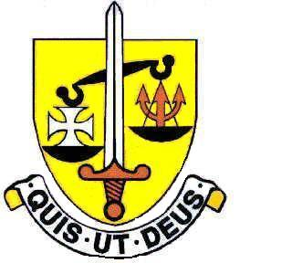 Voluntary Aided
North Finchley “An outstandingly effective School” Ofsted

London N12 7NJ
Tel: 020 8446 2256

Email: applications@st-michaels.barnet.sch.uk

4 Form Entry Voluntary Aided Grammar School for Girls with Boys in the Sixth Form
855 on Roll. 220 in Sixth Form.

Teachers of English
2 Full-time Posts (part-time applicants will be considered)
TLR for Second in Department may be available for a suitably qualified candidate
Salary – Main to Upper Scale

To start 1st September 2024

The Governors are seeking to appoint two enthusiastic Teachers of English to this selective school, FIVE times judged OUTSTANDING by OFSTED (the most recent Inspection being November 2022), which is committed to the ideals of Catholic education and where GCSE and A Level results are consistently excellent.

These roles are suitable for experienced teachers or those new to the profession or in the first few years of their teaching career. The successful candidate will enjoy the challenge of teaching well-motivated and intelligent students across all Key Stages in this selective school.

The English Rooms are in a modern building and equipped with the latest technology to aid teaching.

The school provides a very rewarding working environment where employees are valued and there is a focus on staff welfare.

An application form, job description and departmental information are available on the school website.

Please send completed applications to applications@st-michaels.barnet.sch.uk.

Closing date: Tuesday 21st May midday – early applications are encouraged as we reserve the right to call candidates to interview before this advert is withdrawn.

We are committed to safeguarding and promoting child welfare
The post is subject to an enhanced DBS check
St. Michael’s is committed to equal opportunities, we welcome applications from all sections of the community

