ST. MICHAEL’S CATHOLIC GRAMMAR SCHOOL

Nether Street 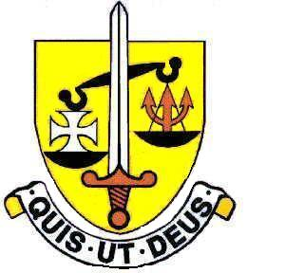 Voluntary Aided
North Finchley “An outstandingly effective School” Ofsted

London N12 7NJ
Tel: 020 8446 2256 Email: office@ st-michaels.barnet.sch.uk
Fax: 020 8343 9598 Website: www.st-michaels.barnet.sch.uk

4 Form Entry Voluntary Aided Grammar School for Girls with Boys in the Sixth Form
850 on Roll. 240 in Sixth Form.

Teacher of Geography
Salary scale Main or Upper

To start 1st November 2023

The Governors are seeking to appoint an enthusiastic and well-qualified Teacher of Geography to this selective school which has been FIVE times judged OUTSTANDING by OFSTED, the most recent Inspection being November 2022.

The successful candidate will teach Geography in all Key Stages – Geography is a popular subject at GCSE and A Level and examination results are outstanding – with pupils continuing to study to degree level at prestigious universities including Oxbridge.

This opportunity will ideally suit someone who enjoys teaching well-motivated and intelligent pupils in an academic school which is committed to the ideals of Catholic education. The school provides a very rewarding working environment where employees are valued and there is a focus on staff welfare.

Application forms are available on the school website. Please send completed forms to applications@st-michaels.barnet.sch.uk.

Closing date: Friday 8th September 2023 midday – early applications are encouraged as we reserve the right to call candidates to interview before this advert is withdrawn.

We are committed to safeguarding and promoting child welfare
The post is subject to an enhanced DBS check
St Michael’s is an equal opportunities employer - applications are welcome from all sections of the community

