ST.MICHAEL’S CATHOLIC GRAMMAR SCHOOL

Nether Street 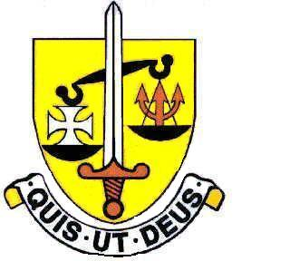 Voluntary Aided
North Finchley “An outstandingly effective School” Ofsted

London N12 7NJ
Tel: 020 8446 2256 Email: office@ st-michaels.barnet.sch.uk
Fax: 020 8343 9598 Website: www.st-michaels.barnet.sch.uk

4 Form Entry Voluntary Aided Grammar School for Girls with Boys in the Sixth Form
860 on Roll. 220 in Sixth Form.
Head of Religious Education
Main or Upper Salary Scale
plus Teaching & Learning Responsibility (currently £11,420)

Required 1st September 2024

Applicants for this post must be practising Roman Catholics.

The Governors are seeking to appoint a Head of Religious Education. The successful candidate will lead the teaching of RE from Year 7 to Year 13, as well as assisting with the preparation of liturgies and retreats.

The ideal candidate will enjoy the challenge of teaching well-motivated and able pupils in an academic school, FIVE times judged OUTSTANDING by OFSTED, the most recent Inspection being November 2022. St. Michael’s is committed to living out its mission as a Catholic school – in particular preparing its students to fulfil positions of influence in our society and thereby changing this world for the better. Our Section 48 inspection (November 2018) also judged the school as outstanding.

GCSE and A Level Religious Studies courses are well established and examination results are
excellent (GCSE RE has consistently the best results of any subject in the school and is highly valued by students). This post would attract a well-qualified and enthusiastic experienced graduate who would enjoy teaching highly motivated, intelligent pupils and working with dedicated colleagues. Students at the school are very well behaved, and the school is a very pleasant working environment where employees are valued and there is a focus on staff welfare and the ethos of the school as a Loreto school - inspired by the life and legacy of Mary Ward.

Application forms are available on the school website. Please send completed forms to applications@st-michaels.barnet.sch.uk.

Closing date: Friday 26th January 2024 midday – early applications are encouraged as we reserve the right to call candidates to interview before this advert is withdrawn.

We are committed to safeguarding and promoting child welfare
The post is subject to an enhanced DBS check
St Michael’s is an equal opportunities employer - applications are welcome from all sections of the community

