ST.MICHAEL’S CATHOLIC GRAMMAR SCHOOL

Nether Street 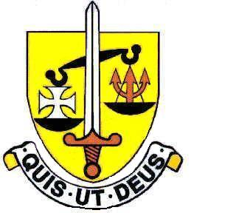 Voluntary Aided
North Finchley “An outstandingly effective School” Ofsted

London N12 7NJ
Tel: 020 8446 2256

Email: applications@st-michaels.barnet.sch.uk

4 Form Entry Voluntary Aided Grammar School for Girls with Boys in the Sixth Form
850 on Roll. 240 in Sixth Form.

Librarian & Reprographics Assistant 15 hours per week, 39 weeks per year
Monday to Friday 10am to 1pm
Unified Reward Grade C
(£25,212 to £26,472 FTE) – Actual salary £9,239 to £9,701
Favourable pension scheme
Required 1st September 2023

The Governors are seeking to appoint a Librarian & Reprographics Assistant to support the Librarian & Reprographics Officer in the provision of a purposeful, orderly and supportive working environment in the School Library before, during and after school.

This person also provides support in the provision of media resources, bulk photocopying for teachers and support staff and ensuring the smooth running of printers around the school - ideally suited to this role would be someone with excellent communication skills, the ability to multi-task and an enthusiastic outlook.

The school provides a very rewarding working environment where employees are valued and there is a focus on staff welfare.

Closing date: Friday 14th July - Interviews the following week. Early applications are encouraged as we reserve the right to call candidates to interview before this advert is withdrawn.

A Support Staff application form and Job Description are available on our website.

Please send applications to applications@st-michaels.barnet.sch.uk

We are committed to safeguarding and promoting child welfare
The post is subject to an enhanced DBS check
St Michael’s is an equal opportunities employer - applications are welcome from all sections of the community

