ST. MICHAEL’S CATHOLIC GRAMMAR SCHOOL

Nether Street 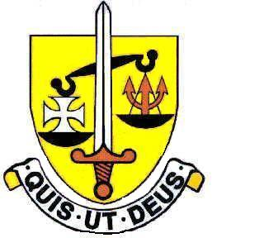 Voluntary Aided
North Finchley “An outstandingly effective School” Ofsted

London N12 7NJ
Tel: 020 8446 2256

Email: applications@st-michaels.barnet.sch.uk

4 Form Entry Voluntary Aided Grammar School for Girls with Boys in the Sixth Form
850 on Roll. 250 in Sixth Form.

Modern Foreign Languages Assistant - Italian
Barnet Unified Reward Grade F Max – £16.90 per hour
Fixed Term, Part-time, term time only - 5 hours per week

Required from 1st October 2023 to 31st May 2024

The Governors are seeking to appoint a Modern Foreign Languages Assistant, specialising in Italian, to work flexibly for 5 hours per week supporting A Level students.

This person will join a successful Modern Foreign Languages Department in this selective school, FIVE times judged OUTSTANDING by OFSTED (the most recent Inspection being November 2022) which is committed to the ideals of Catholic education and where exam results are consistently excellent. Language Assistants for Spanish and French are also part of the team. The successful candidate will work under the direction of the Teacher in Charge of Italian and will help students in their preparation for the oral component of public examinations. Ideally suited to this role would be someone enthusiastic and dedicated to promoting the study and enjoyment of Italian, with a willingness to play an active role within the department.

The school provides a very rewarding working environment where employees are valued and there is a focus on staff welfare.

A Support Staff application form and job description are available on our website.

Please send completed applications to applications@st-michaels.barnet.sch.uk.

Closing date: Monday 3rd July 2023 – midday - early applications are encouraged as we reserve the right to call candidates to interview before this advert is withdrawn.

We are committed to safeguarding and promoting child welfare. The post is subject to an enhanced DBS check. St Michael’s is an equal opportunities employer - applications are welcome from all sections of the community

