ST. MICHAEL’S CATHOLIC GRAMMAR SCHOOL

Nether Street 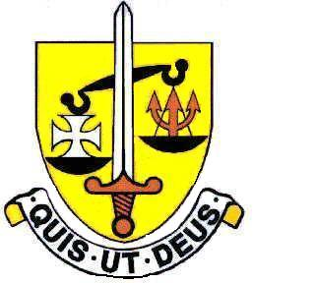 Voluntary Aided
North Finchley “An outstandingly effective School” Ofsted

London N12 7NJ
Tel: 020 8446 2256 Email: office@ st-michaels.barnet.sch.uk
Fax: 020 8343 9598 Website: www.st-michaels.barnet.sch.uk

4 Form Entry Voluntary Aided Grammar School for Girls with Boys in the Sixth Form
890 on Roll. 250 in Sixth Form.

Full or Part-time Teacher of Religious Education
Main or Upper Scale

Required 1st September 2025

The Governors are seeking to appoint a teacher of Religious Education. The successful candidate will teach RE at all Key Stages, as well as assisting with the preparation of liturgies.

The ideal candidate will enjoy the challenge of teaching well-motivated and able pupils in an academic school, five times judged outstanding by Ofsted (the most recent Inspection being November 2022) which is committed to living out its mission as a Catholic school – in particular preparing its students to fulfil positions of influence in our society and thereby changing this world for the better. Our Catholic Schools Inspection in October 2024 judged the school as outstanding.

GCSE and A Level Religious Studies courses are well established and examination results are excellent. This post is equally suitable for a well-qualified, experienced teacher or those new to the profession. Students at the school are very well behaved and the school is a very pleasant working environment. Employees are valued and there is a focus on staff welfare.

An application form is available on the school website. Please send completed forms to applications@st-michaels.barnet.sch.uk.

Closing date: Monday 19th May 2025 9am – early applications are encouraged as we reserve the right to call candidates to interview before this advert is withdrawn.

We are committed to safeguarding and promoting child welfare
The post is subject to an enhanced DBS check
St Michael’s is an equal opportunities employer – applications are welcome from all sections of the community

