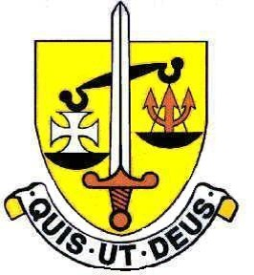

The Science Department

This is a very successful and lively department. We offer both Combined and Triple Science at GCSE and we have a large number of students staying on to take Science subjects in the Sixth Form. We also attract many new students from other schools into Year 12 to take Biology, Chemistry and Physics at A Level.

Staff
There are currently twelve staff in Science teaching. There are Teaching and Learning Responsibility posts for Head of Science (Biology), Head of Physics and Head of Chemistry.

We are well supported by Technicians in each department.

Laboratories
There are seven well equipped laboratories.

The Curriculum
Key Stage 3 – In Years 7 and 8 the girls are taught Science in their form groups. In year 9 the group sizes are smaller. During the course of Years 7, 8 and 9 two topic units each of Biology, Chemistry and Physics are taught. We have developed our own schemes of work based on the Pearson ‘Exploring Science’ units which we have used since 2022. We provide a varied and challenging course with plenty of practical work.

Key Stage 4 – All students are taught by separate subject specialist teachers for the Biology, Chemistry and Physics components of the Combined Science or separate three sciences course. We follow the Edexcel GCSE specification. Although Science is a compulsory subject to GCSE a high percentage of students achieve top grades and the percentage of students achieving 7 or above is around 90%.

A Levels – Biology and Physics both study the AQA specification, while Chemistry studies EXEXCEL.
A Level results are excellent. Teaching is usually shared between two teachers in each subject. There are currently eight Biology, eight Chemistry and four Physics groups.

We are looking for an enthusiastic and well qualified scientist to join the Physics team. In addition, participation in departmental visits would be expected.

May 2024

