ST. MICHAEL’S CATHOLIC GRAMMAR SCHOOL

Nether Street 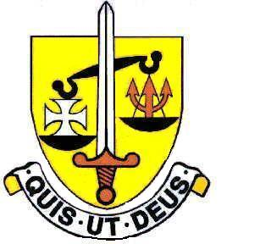 Voluntary Aided
North Finchley “An outstandingly effective School” Ofsted

London N12 7NJ
Tel: 020 8446 2256 Email: office@ st-michaels.barnet.sch.uk
Fax: 020 8343 9598 Website: www.st-michaels.barnet.sch.uk

4 Form Entry Voluntary Aided Grammar School for Girls with Boys in the Sixth Form
850 on Roll. 220 in Sixth Form.

Temporary Part-time Teacher of Spanish & French – Maternity Cover
Salary scale Main or Upper
0.4 Contract – Monday & Tuesday
To start June 2024

The Governors are seeking to appoint an enthusiastic and well-qualified Teacher of Spanish & French for this temporary contract while the incumbent is on maternity leave.

St. Michael’s is a selective school, five times judged OUTSTANDING by OFSTED - the most recent Inspection being November 2022 - and found to be outstanding in a Diocesan Inspection in December 2018.

The successful candidate will join a vibrant and thriving Modern Foreign Languages Department and will teach Spanish to GCSE (with the possibility of A Level) and KS3 French. MFL examination results are very good.

This post would ideally suit someone passionate about their subject and eager to teach to the highest level. Students are highly motivated and intelligent. Behaviour is outstanding at this school which is committed to the ideals of Catholic education and enables its students to thrive and to fulfil their aspirations for the future.

The school provides a very rewarding working environment where employees are valued and there is a focus on staff welfare.

Closing date: Wednesday 20th March midday - early applications are encouraged as we reserve the right to call candidates to interview before this advert is withdrawn.

An application pack is available on the school website. Please send completed forms to applications@st-michaels.barnet.sch.uk.

We are committed to safeguarding and promoting child welfare
The post is subject to an enhanced DBS check
St Michael’s is an equal opportunities employer - applications are welcome from all sections of the community

