ST. MICHAEL’S CATHOLIC GRAMMAR SCHOOL

Nether Street 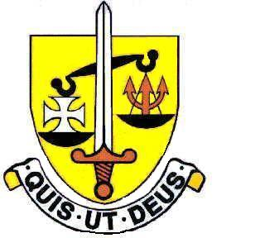 Voluntary Aided
North Finchley “An outstandingly effective School” Ofsted

London N12 7NJ
Tel: 020 8446 2256 Email: office@ st-michaels.barnet.sch.uk
Fax: 020 8343 9598 Website: www.st-michaels.barnet.sch.uk
4 Form Entry Voluntary Aided Grammar School for Girls with Boys in the Sixth Form
855 on Roll. 282 in Sixth Form.

Sixth Form Student Support Assistant
30 hours per week, Monday to Friday 8.30am to 3.30pm, 39 weeks per year,
Unified Reward Grade F - Actual Salary £19,342 to £21,527 (FTE £26,508 to £29,502)

Required 1st September 2022.

This role is in response to a school-wide focus on improving student mental health and wellbeing.
St Michael’s Catholic Grammar School is a small school with a distinctive Catholic ethos. Students at the school are very well behaved and the school is a very pleasant working environment.

The Governors are seeking to appoint a Student Support Assistant to work especially with sixth form students, both in terms of supervising the sixth form study rooms and supporting individual students. The purpose of this role is to ensure that the sixth form study rooms are silent spaces for study and learning and to provide individual support for students. This support will help students to cope with the demand placed upon them by school and home in the face of difficulties which their lives present – such as organisation issues, anxiety, bereavement and many other issues prevalent among young people. The focus is to remove barriers which inhibit learning and self-fulfilment.

The appointed person would be approachable and confident in speaking to individuals or small groups of young people. They should also be confident in speaking to large groups of students in terms of maintaining silence and order in the study rooms. Good organisation skills are necessary, as is the ability to deal with distressing situations as well as with parents, other staff and external agencies. Recording notes and communications by email and phone are also features of this post. The appointed person will support the Head of Sixth Form with monitoring of attendance and punctuality at Key Stage 5.

This person will work under the direction of the Deputy Headteacher and in conjunction with other staff. Ideally suited to this role would be someone with an enthusiastic outlook who enjoys a hands-on approach to solving problems. The appointed candidate will be flexible in their approach to the work undertaken and be able to make adjustments in order to face unexpected issues which may present themselves. The ability to manage a range of competing demands and to prioritise work is very important.

Closing date: Tuesday 12th July – Midday - interviews will take place that week – A Support Staff application form can be found on the school website; please return to applications@st-michaels.barnet.sch.uk
We are committed to safeguarding and promoting child welfare
The post is subject to an enhanced DBS check
St Michael’s is an equal opportunities employer - applications are welcome from all sections of the community

