ST. MICHAEL’S CATHOLIC GRAMMAR SCHOOL

Nether Street 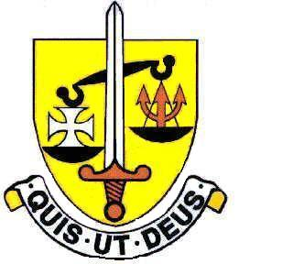 Voluntary Aided
North Finchley “An outstandingly effective School” Ofsted

London N12 7NJ
Tel: 020 8446 2256 Email: office@ st-michaels.barnet.sch.uk
Fax: 020 8343 9598 Website: www.st-michaels.barnet.sch.uk

4 Form Entry Voluntary Aided Grammar School for Girls with Boys in the Sixth Form
860 on Roll. 280 in Sixth Form.

Two Science Technician posts available, both Part-time 30 hours per week, 39 weeks per year (term time only)
Unified Rewards Grade C: actual salary £16,770 to £17,689 (FTE £22,983 to £24,243)
Monday to Friday 8am to 2pm
One post: Physics Specialist
One post: Biology Specialist

Required 1st September 2022

The Governors are seeking to appoint two Technicians to provide specialist support to our Physics and Biology Departments. Duties are wide-ranging and will include (amongst others): support to pupils in accessing the curriculum, preparation and maintenance of resources as required by staff for lesson planning. In addition, this post encompasses support of practical activities with groups or one-to-one including the use of specialised equipment and technology. St Michael’s Catholic Grammar School is a selective school with a distinctive Catholic ethos. Students at the school are very well behaved and the school is a very pleasant working environment.

The Technicians will work under the direction of the Heads of Department and Subject Teachers. School experience would be desirable but is not essential.

The appointed candidate will be flexible in their approach to the wide-range of work undertaken – and will be an intrinsic part of the support staff team. The ability to manage a range of competing demands and to prioritise work is very important. Very good levels of both written and spoken English are essential.

A Support Staff application form and Job Description are available on the School website.

Please send completed applications to applications@st-michaels.barnet.sch.uk.

Closing date: Monday 11th July midday.

We are committed to safeguarding and promoting child welfare
The post is subject to an enhanced DBS check
St Michael’s is an equal opportunities employer - applications are welcome from all sections of the community

