ST. MICHAEL’S CATHOLIC GRAMMAR SCHOOL

Nether Street 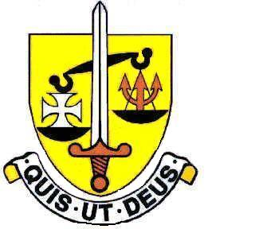 Voluntary Aided
North Finchley “An outstandingly effective School” Ofsted

London N12 7NJ
Tel: 020 8446 2256 Email: office@ st-michaels.barnet.sch.uk
Fax: 020 8343 9598 Website: www.st-michaels.barnet.sch.uk

4 Form Entry Voluntary Aided Grammar School for Girls with Boys in the Sixth Form
860 on Roll. 220 in Sixth Form.

Technician Physics, Part-time 30 hours per week, 39 weeks per year (term time only)
Unified Rewards Grade C: actual salary £20,111 to £21,034 (FTE £27,438 to £28,698)
Monday to Friday 8am to 2pm

Required January 2024

The Governors are seeking to appoint a Technician to provide specialist support to our Physics Department. Duties are wide-ranging and will include (amongst others): support to pupils in accessing the curriculum, preparation and maintenance of resources as required by staff for lesson planning. In addition, this post encompasses support of practical activities with groups or one-to-one including the use of specialised equipment and technology. St Michael’s Catholic Grammar School is a selective school with a distinctive Catholic ethos. Students at the school are very well behaved and the school is a very pleasant working environment.

The Technician will work under the direction of the Head of Department and Subject Teachers. School experience would be desirable but is not essential. The school provides a very rewarding working environment where employees are valued and there is a focus on staff welfare.

The appointed candidate will be flexible in their approach to the wide-range of work undertaken – and will be an intrinsic part of the support staff team. The ability to manage a range of competing demands and to prioritise work is very important. Very good levels of both written and spoken English are essential.

A Support Staff application form and Job Description are available on the School website.

Please send completed applications to applications@st-michaels.barnet.sch.uk.

Closing date: Monday 15th January midday - early applications are encouraged as we reserve the right to call candidates to interview before this advert is withdrawn.

We are committed to safeguarding and promoting child welfare
The post is subject to an enhanced DBS check
St Michael’s is an equal opportunities employer - applications are welcome from all sections of the community

